1. INTRODUCTION
1.1. Project Overview
The project focuses on the use of an AI-powered system, Civil Engineering Insight Studio, to assist construction supervisors in identifying and managing materials used at a building construction site. By uploading images of the construction area, the system analyzes visual data using image recognition and computer vision techniques to detect materials such as concrete, steel, and bricks. The tool then generates a detailed report that includes the type of materials present, their estimated quantity, and their location within the structure, helping supervisors gain a clear understanding of material usage.
This approach reduces the need for manual inspection and improves efficiency in construction monitoring and documentation. The system supports better planning and decision-making by providing accurate and organized material information, which helps in resource management and progress tracking. Overall, the project aims to enhance productivity, improve accuracy, and support modern digital practices in construction management through intelligent automation.
1.2. Objectives
The main objectives of the Civil Engineering Insight Studio project are:
- To develop an AI-based system for automatic identification of construction materials from site images.
- To accurately identify materials such as concrete, steel, and bricks used in construction.
- To reduce manual inspection time and effort for construction supervisors.
- To improve material tracking and documentation during construction activities
- To support better decision-making through clear and organized material reports.
- To minimize human errors in material identification and reporting.
2. Ideation Phase
2.1. Problem Statement
The problem is the lack of a quick and reliable method to analyze construction materials directly from site images and obtain accurate information about material type, quantity, and location. Therefore, the problem statement highlights the need for an intelligent tool, such as Civil Engineering Insight Studio, that can automate material identification and provide clear insights to improve decision-making, save time, and reduce errors in construction management.
Problem  Statement  (PS) | I am | I’m trying to | But | Because | Which makes me feel
PS-1 | A food blogger | Create detailed, and high-quality recipe blog content in less time | Writing long and recipe blogs manually is time-consuming | It requires research, creativity, formatting, and consistency | Frustrated and less productive
PS-2 | A cooking enthusiast | Generate customized recipes | Existing recipes available online are generic and not customizable | Most platforms do not offer AI-driven recipe blog generation | Dissatisfied and overwhelmed while planning meals

2.2. Empathy Map Canvas
Empathy Map Canvas:
An empathy map is a simple, easy-to-digest visual that captures knowledge about a user’s behaviours and attitudes.

It is a useful tool to helps teams better understand their users.
Creating an effective solution requires understanding the true problem and the person who is experiencing it. The exercise of creating the map helps participants consider things from the user’s perspective along with his or her goals and challenges.
Example:
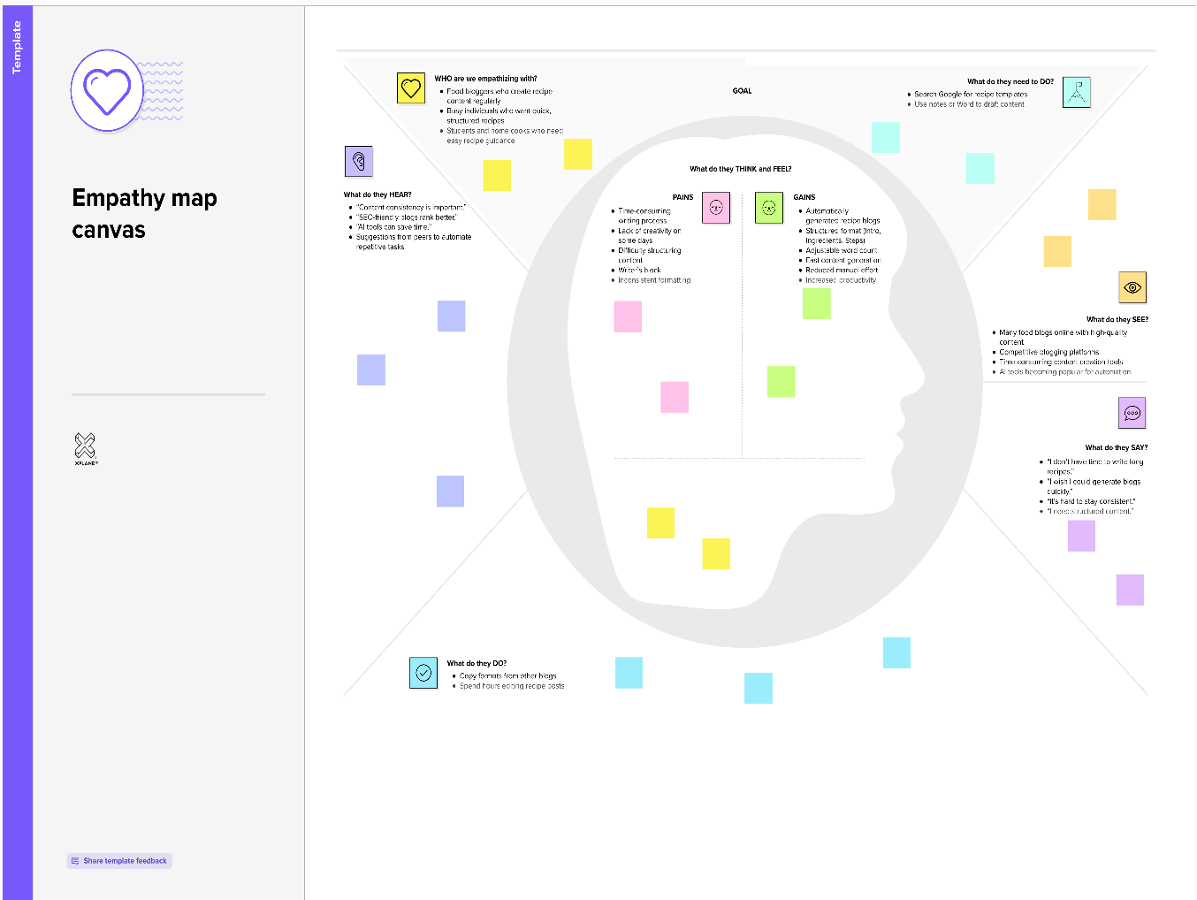

2.3 Brainstorming
Brainstorm & Idea Prioritization:
Brainstorming provides a free and open environment that encourages everyone within a team to participate in the creative thinking process that leads to problem solving. Prioritizing volume over value, out-of-the-box ideas are welcome and built upon, and all participants are encouraged to collaborate, helping each other develop a rich amount of creative solutions.
Use this template in your own brainstorming sessions so your team can unleash their imagination and start shaping concepts even if you're not sitting in the same room.

Step-1: Team Gathering, Collaboration and Select the Problem Statement
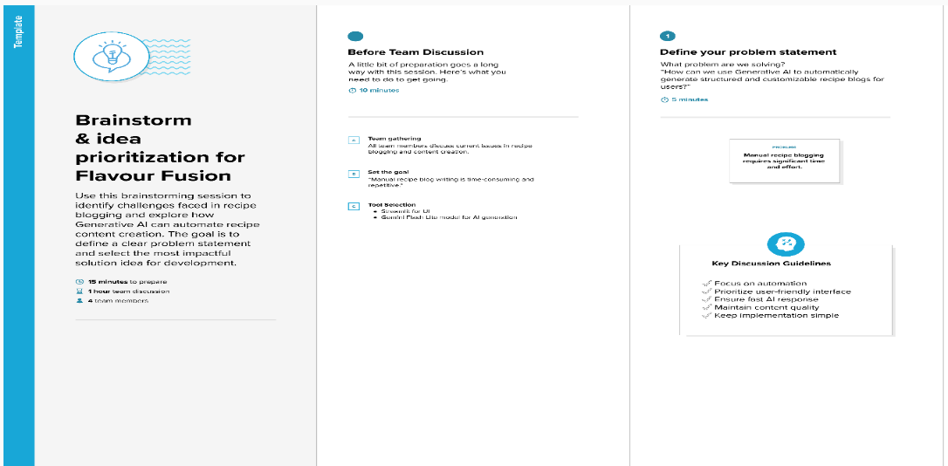

Step-2: Brainstorm, Idea Listing and Grouping
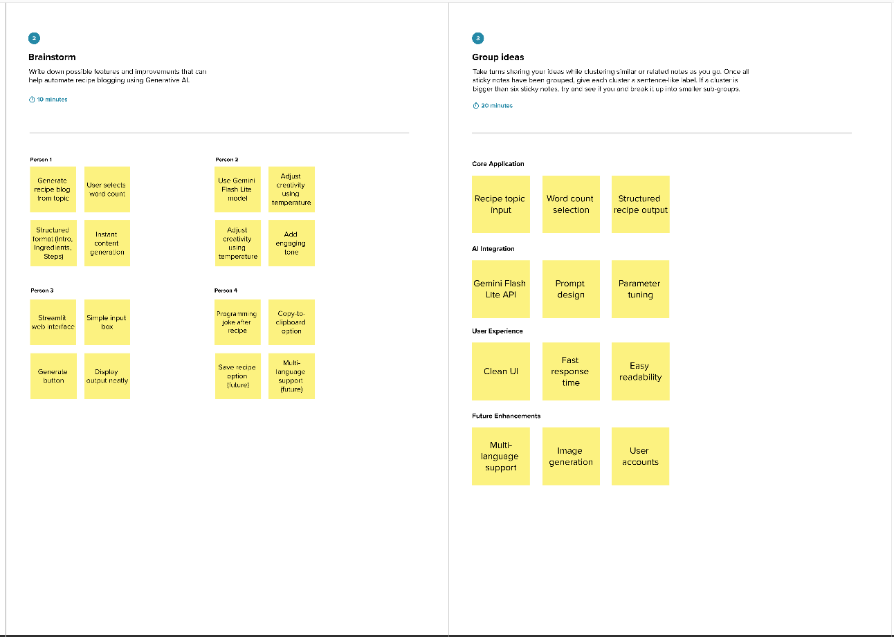

Step-3: Idea Prioritization
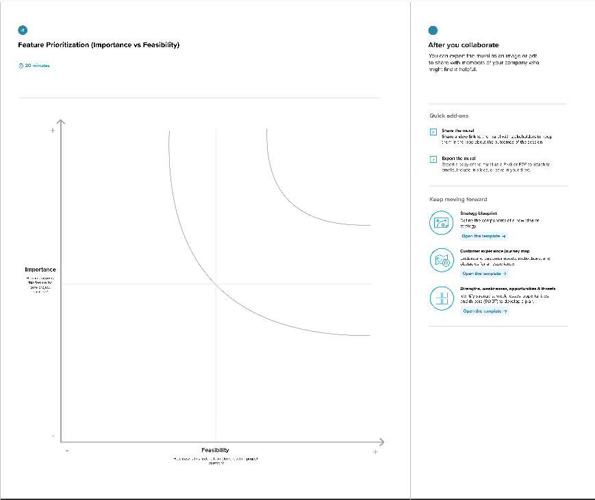

3. Requirement Analysis
3.1. Solution Requirement
Functional Requirements:
Following are the functional requirements of the proposed solution.
FR No. | Functional Requirement (Epic) | Sub Requirement (Story / Sub-Task)
FR-1 | Sturcture Input Module | Enter consturction structure name  Select web browser
FR-2 | Input Validation | Validate empty input  Validate photo insertion
FR-3 | AI Integration | Connect to Gemini Flash Lite API  Send structured prompt to model
FR-4 | Data Generation | Generate structured recipe blog  Include introduction, ingredients, steps
FR-5 | Output Display | Display generated data regarding to user inserted data
FR-6 | Additional Feature | Generate programming joke (optional feature)

Non-functional Requirements:
Following are the non-functional requirements of the proposed solution.
FR No. | Non-Functional Requirement | Description
NFR-1 | Usability | The application must have a simple and intuitive Streamlit interface that is easy to use.
NFR-2 | Security | API keys must be securely stored and not exposed in the frontend.
NFR-3 | Reliability | The system should generate consistent and structured outputs for valid inputs.
NFR-4 | Performance | Data generation should complete within a few seconds.
NFR-5 | Availability | The application should be accessible online whenever deployed.
NFR-6 | Scalability | The system should handle multiple users without significant performance degradation.

3.2. Data Flow Diagram
Data Flow Diagrams:
A Data Flow Diagram (DFD) is a traditional visual representation of the information flows within a system. A neat and clear DFD can depict the right amount of the system requirement graphically. It shows how data enters and leaves the system, what changes the information, and where data is
Sorted.

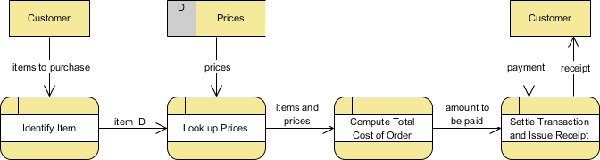

User Stories
Use the below template to list all the user stories for the product.
User Type | Functional Requirement (Epic) | User Story Number | User Story / Task | Priority | Release
Customer (Mobile user) | User Interface Setup | USN-1 | As a user, I can access a Streamlit-based interface to enter a recipe topic and word count. | High | Sprint-1
Administrator | Input Validation | USN-2 | As a user, I want the application to validate my inputs before generating the recipe. | High | Sprint-1
Customer Care Executive | AI Model Integration | USN-3 | As a user, I want the system to generate a recipe blog using the Gemini Flash Lite model. | High | Sprint-2
Administrator | Joke Generation | USN-4 | As a user, I want to see a programming joke while the recipe is being generated. | Medium | Sprint-2
Customer (Mobile user) | Output Display | USN-5 | As a user, I want to view the generated recipe blog clearly on the screen. | High | Sprint-3
Customer Care Executive | Deployment | USN-6 | As a user, I want the application to be deployed and accessible through the internet. | Medium | Sprint-3
3.3. Technology Stack
Technical Architecture:
The Deliverable shall include the architectural diagram as below and the information as per the table1 & table 2
Table-1 : Components & Technologies:
S.No | Component | Description | Technology
 | User Interface | Web-based interface where users enter structure name and photo | Streamlit (Python Web Framework)
 | Application Logic-1 | Input validation and prompt construction logic | Python
 | Application Logic-2 | AI request handling and response processing | Google Generative AI API
 | Application Logic-3 | Data formatting and output structuring | Python
 | File Storage | Local environment for source code and logs | Local File System
 | External API-1 | Generative AI service for information generation | Gemini Flash Lite (models/gemini-flash-lite-latest)
 | Machine Learning Model | Pre-trained generative AI model for data generation | Gemini Flash Lite Model
 | Infrastructure (Server / Cloud) | Deployment of application | Streamlit Cloud / Local Deployment
Table-2: Application Characteristics:
S.No | Characteristics | Description | Technology
 | Open-Source Frameworks | Web framework and development tools used | Streamlit, Python
 | Security Implementations | Secure storage of API keys and environment variables | Environment Variables (.env), Streamlit Secrets
 | Scalable Architecture | Web-based architecture supporting multiple users | Cloud-based deployment (Streamlit Cloud)
 | Availability | Application accessible online after deployment | Streamlit Cloud Hosting
 | Performance | Fast response generation using lightweight AI model | Gemini Flash Lite (optimized for low latency)

4. PROJECT DESIGN
4.1. Problem Solution Fit
Problem – Solution Fit Template:
The Problem-Solution Fit simply means that you have found a problem with your customer and that the solution you have realized for it actually solves the customer’s problem. It helps entrepreneurs, marketers and corporate innovators identify behavioral patterns and recognize what would work and why
Purpose:
- Solve complex problems in a way that fits the state of your customers.
- Succeed faster and increase your solution adoption by tapping into existing mediums and channels of behavior.
- Sharpen your communication and marketing strategy with the right triggers and messaging.
- Increase touch-points with your company by finding the right problem-behavior fit and building trust by solving frequent annoyances, or urgent or costly problems.
- Understand the existing situation in order to improve it for your target group.

Template:


4.2. Proposed Solution
Proposed Solution Template:
Project team shall fill the following information in the proposed solution template.
S.No. | Parameter | Description
 | Problem Statement (Problem to be solved) | In modern construction projects, supervisors face challenges in accurately identifying and documenting materials used at various stages of building development. Manual inspection of construction materials such as concrete, steel, and bricks is time-consuming, prone to human error, and often lacks detailed documentation regarding material quantity and placement within the structure.
 | Idea / Solution description | The ideal solution is to develop an AI-powered image analysis system integrated within the Civil Engineering Insight Studio that enables construction supervisors to automatically identify and document materials used on-site. The system should allow users to upload construction site images and optionally provide contextual notes. Using advanced computer vision and generative AI models, the tool would analyze the image to detect construction materials such as concrete, steel, and bricks, estimate their quantities, and determine their locations within the structure.
 | Novelty / Uniqueness | The novelty of the Civil Engineering Insight Studio lies in its integration of artificial intelligence and computer vision specifically tailored for civil engineering applications. Unlike traditional construction monitoring methods that rely heavily on manual inspection and documentation, this system introduces an automated, image-based material identification approach.
 | Social Impact / Customer Satisfaction | The Civil Engineering Insight Studio project has a positive social impact by promoting safer, more efficient, and higher-quality construction practices. By enabling accurate identification and documentation of construction materials, the system helps ensure that appropriate materials are used in building projects, reducing the risk of structural failures and enhancing public safety. Improved monitoring and quality control contribute to stronger and more reliable infrastructure, which directly benefits communities.
 | Business Model (Revenue Model) | The Civil Engineering Insight Studio can adopt business model, offering AI-powered material identification and structural analysis as a subscription-based web application. Construction companies, contractors, engineering consultants, and infrastructure firms can subscribe to the platform to access image-based analysis tools that improve site monitoring and documentation efficiency.
 | Scalability of the Solution | The Civil Engineering Insight Studio is designed to be highly scalable, both technically and operationally. Since the system is built as a web-based application using AI APIs, it can handle increasing numbers of users and image uploads by leveraging cloud infrastructure. As demand grows, the application can scale horizontally by adding more servers or cloud instances to manage higher traffic and processing loads without affecting performance.

4.3 Solution Architecture
Solution Architecture:
The Civil Engineering Insight Studio follows a layered, modular architecture that integrates a web-based user interface with an AI-powered image analysis engine through secure cloud APIs. The architecture ensures scalability, security, and efficient data processing.At the presentation layer, the system uses a Streamlit-based web interface where construction supervisors upload images and optionally provide descriptive inputs. This layer handles user interaction, input validation, and result visualization.
Example - Solution Architecture Diagram:
5. PROJECT PLANNING & SCHEDULING
5.1. Project Planning
Product Backlog, Sprint Schedule, and Estimation (4 Marks)
Use the below template to create product backlog and sprint schedule
Product Backlog, Sprint Schedule, and Estimation
The following table represents the product backlog and sprint-wise planning for the Civil Engineering Insight Studio project.
Sprint | Functional Requirement (Epic) | User Story Number | User Story / Task | Story Points | Priority | Team Members
Sprint 1 | User Interface Setup | USN-1 | As a user, I can access a Streamlit-based interface to enter a recipe topic and word count. | 2 | High | All Team Members
Sprint 1 | Input Validation | USN-2 | As a user, I want the application to validate my inputs before generating the recipe. | 1 | High | All Team Members
Sprint 2 | AI Model Integration | USN-3 | As a user, I want the system to generate a recipe blog using the Gemini Flash Lite model. | 3 | High | All Team Members
Sprint 2 | Joke Generation | USN-4 | As a user, I want to see a programming joke while the recipe is being generated. | 1 | Medium | All Team Members
Sprint 3 | Output Display | USN-5 | As a user, I want to view the generated recipe blog clearly on the screen. | 2 | High | All Team Members
Sprint 3 | Deployment | USN-6 | As a user, I want the application to be deployed and accessible through the internet. | 2 | Medium | All Team Members

Project Tracker, Velocity & Burndown Chart: (4 Marks)
Sprint | Total Story Points | Duration | Sprint Start Date | Sprint End Date (Planned) | Story Points Completed (as on Planned End Date) | Sprint Release Date (Actual)
Sprint 1 | 20 | 4 Days | 28 January 2026 | 31 January 2026 | 20 | 31 January 2026
Sprint 1 | 20 | 4 Days | 28 January 2026 | 31 January 2026 | 20 | 31 January 2026
Sprint 2 | 20 | 8 Days | 02 February 2026 | 09 February 2026 | 20 | 09 February 2026
Sprint 2 | 20 | 8 Days | 02 February 2026 | 09 February 2026 | 20 | 09 February 2026
Sprint 3 | 20 | 7 Days | 12 February 2026 | 18 February 2026 | 20 | 18 February 2026
Sprint 3 | 20 | 7 Days | 12 February 2026 | 18 February 2026 | 20 | 18 February 2026

6. FUNCTIONAL AND PERFORMANCE TESTING
6.1 Performance Testing

Test Scenarios & Results
Test Case ID | Scenario (What to test) | Test Steps (How to test) | Expected Result | Actual Result | Pass/Fail
FT-01 | Structure Topic Input Validation | Enter valid structue name and leave web browser fillingas empty | Valid input accepted, error shown for empty input | As Expected | Pass
FT-02 | Data Input Validation | Enter invalid name | Accepts valid input, shows warning for invalid input | As Expected | Pass
FT-03 | AI data Generation | Enter structure name and click “Describe structure” | Structured data with title, materials generated | As Expected | Pass
FT-04 | Gemini API Connection Check | Trigger structure data generation with valid API key | API responds successfully and generates recipe | As Expected | Pass
PT-01 | Response Time Test | Measure time after clicking generate | Structure details generated within 20 seconds | Within Limit | Pass
PT-02 | Multiple Request Handling | Generate multiple structures sequentially | Application handles requests without crash | Stable | Pass
PT-03 | Deployment Test | Access deployed app via browser | Application loads and works correctly online | Working | Pass

6. RESULTS
6.1. Output Screenshots
The complete execution of Civil Engineering Insight Studio application is represented step by step in the following screenshots.
Step 1: To run the Streamlit Application we have to use the command streamlit run app.py in the terminal in path where the app.py file is located.
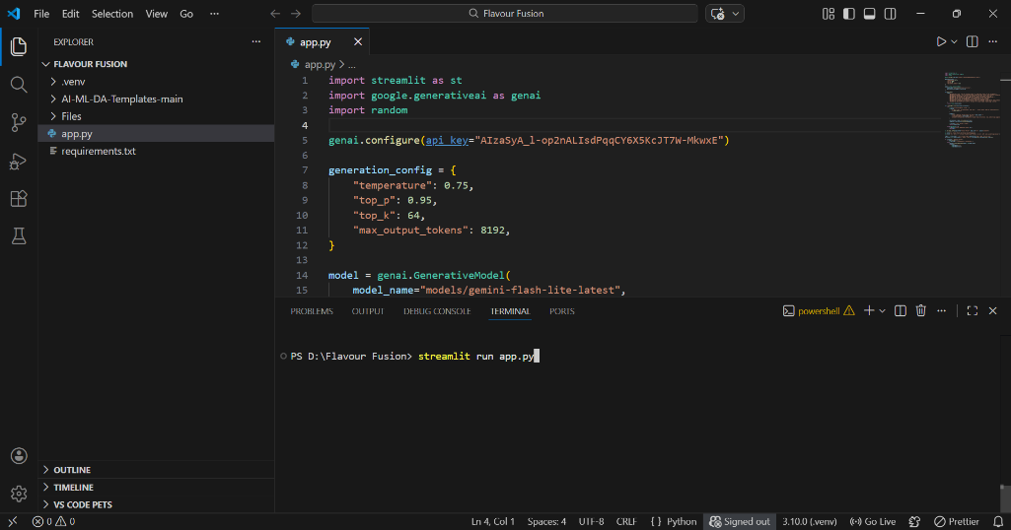
Step 2: After running the command in terminal, the code will get executed and the webpage will open directly. Another way to open webpage is that a localhost link will get generated in the terminal, we can access the webpage using that link.
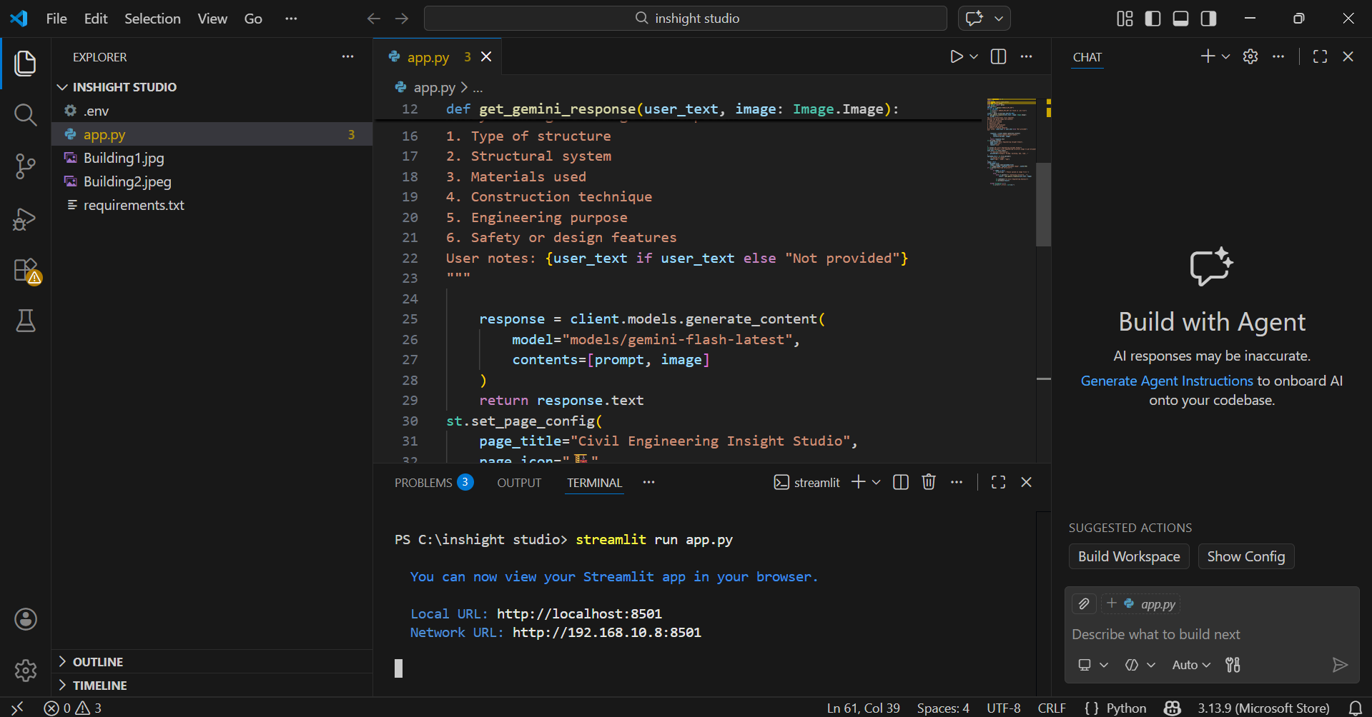

Step 3: The Streamlit webpage opens as shown in the figure given below. This is an automated webpage. No secondary HTML codes required to build this webpage. Python code itself consists the webpage building code.

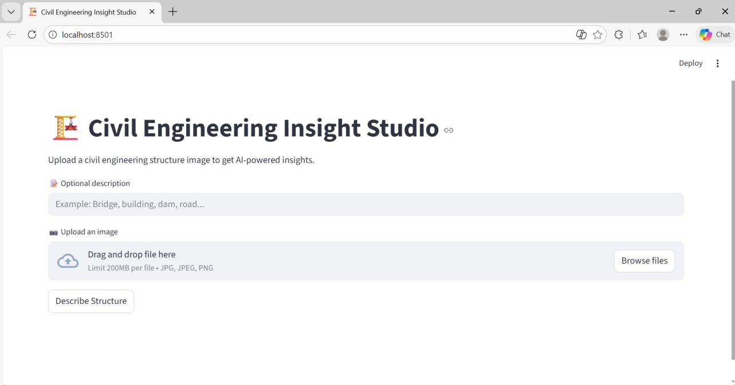
Step 4: The user has to give inputs in the website such as a name of constructions. The material details of the construction should be generate. After entering the required details, the user should click on describe structure button to generate the regarding. Here I chose theglass building 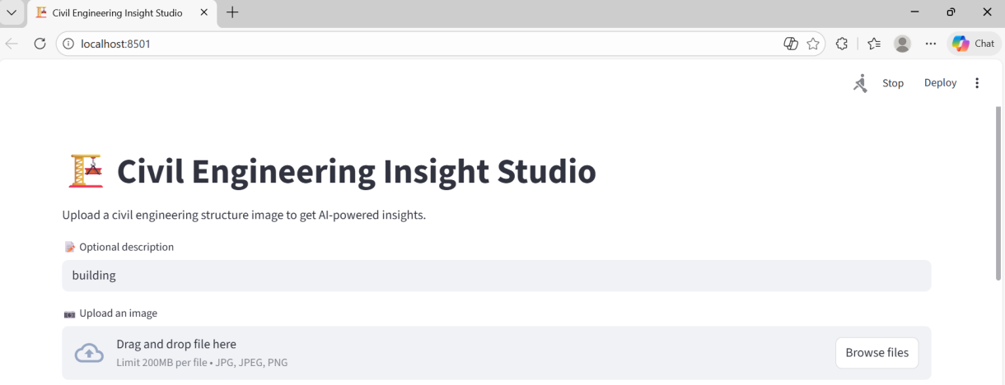
Step 5: After clicking the describe structure button, in fraction of seconds the data related to construction will be generated as shown in the below figure. The construction data will be generated based on the user inputs as shown in the following Three images.
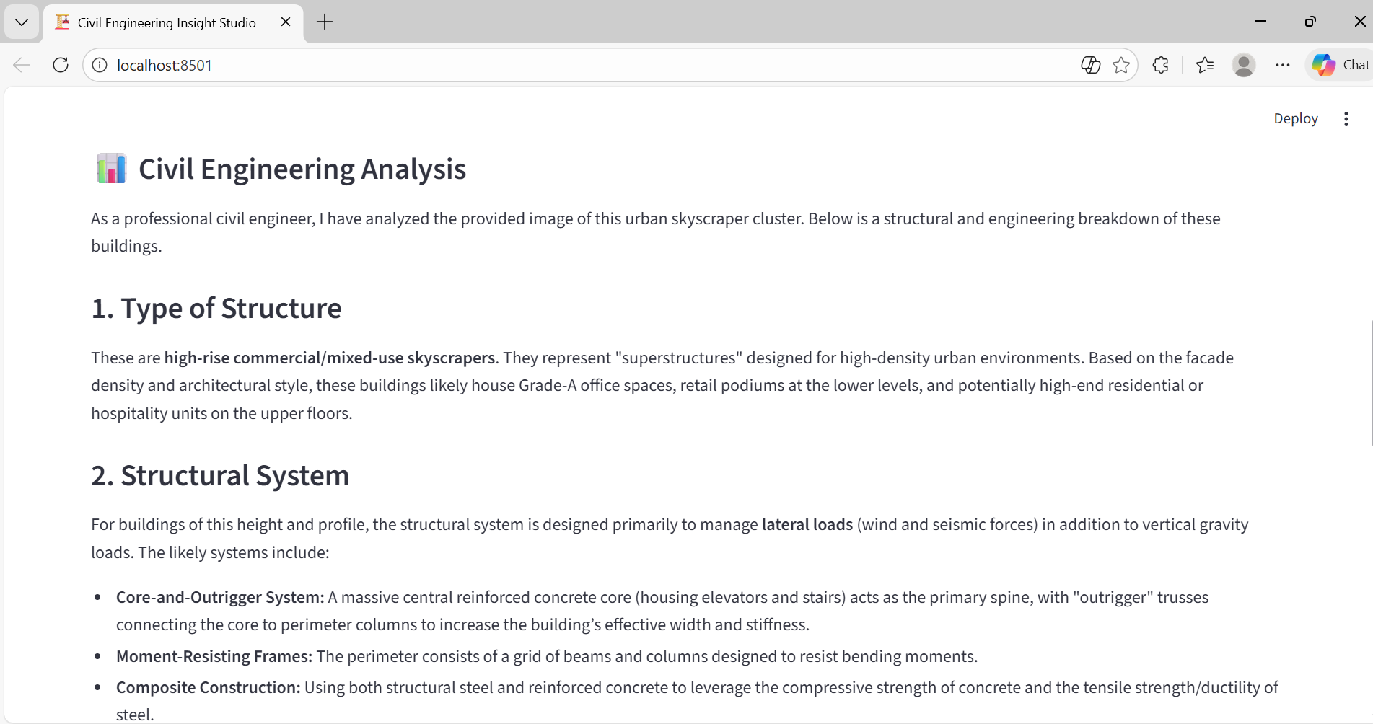
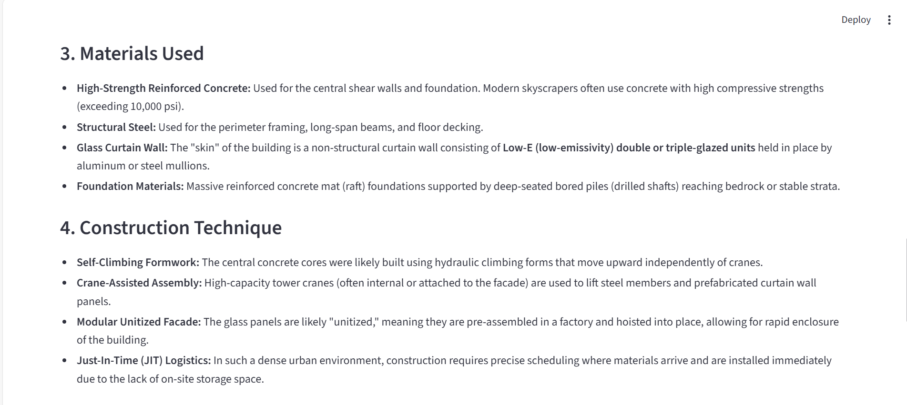
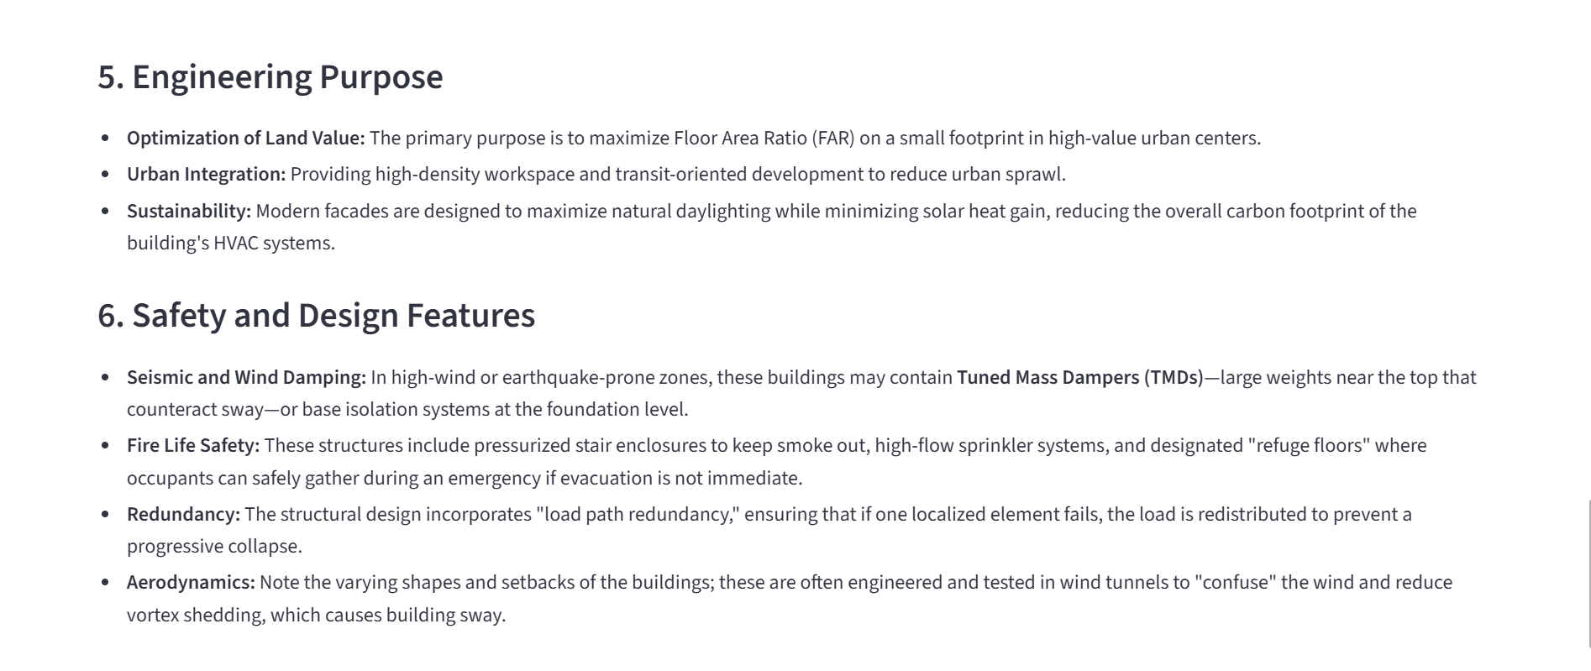
7. ADVANTAGES AND DISADVANTAGES
Advantages
- Saves time by automatically generating detailed data
- Reduces manual effort for providing data
- Generates customized content based on user input
- User-friendly interface built using Streamlit
- Fast and efficient content generation using a pre-trained AI model
- No requirement for dataset collection or model training
Disadvantages
- Requires an active internet connection to access the AI model
- Depends on third-party AI APIs for content generation
- Limited to photo-based content only
- Output quality depends on the clarity of user input

8. CONCLUSION
The project demonstrates how AI-based tools like Civil Engineering Insight Studio can improve efficiency and accuracy in construction management by automatically identifying and analyzing building materials from site images. The system helps reduce manual effort, supports better material tracking, and provides clear insights into material type, quantity, and location within the structure. By combining image analysis with intelligent reporting, the project promotes smarter decision-making, improved resource management, and the adoption of modern digital technologies in the construction industry.
9. FUTURE SCOPE
The future scope of this project includes enhancing the system with advanced AI and computer vision techniques to improve the accuracy of material identification under different environmental conditions such as low lighting, complex backgrounds, and partially visible materials. The system can also be expanded to recognize a wider range of construction materials and structural components, enabling more detailed analysis and reporting for large-scale construction projects.
10. APPENDIX
10.1. Source Code
The source code for the Civil Engineering Insight Studio project includes the implementation of the Streamlit user interface, integration of the Gemini Flash Lite model using the Google Generative AI API, recipe blog generation logic, and the programmer joke feature. The code is written in Python and follows a modular and readable structure.
10.2. Github & Project Demo Link
Github Repository Link: https://github.com/NARASIMHA106525/Civil-Engineering--Insight-Studio
Demo Link:
https://drive.google.com/file/d/1qGJTwDCcrk_z-MSA6DZT14qvd8r7C3jH/view?usp=sharing

